

**Superstore Sales Analysis**

**Report**

**Title**

**Superstore Sales Analysis**

**Objective**

This report analyses the sales performance, profit trends, and customer purchasing behaviour of a superstore. The objective is to identify key revenue drivers, assess product profitability, and evaluate sales distribution across regions and categories.

**Data Source & Preparation**

* **Data Source:** Kaggle’s Superstore Sales Dataset
* **Data Cleaning & Preprocessing:**
* Removed duplicate records for data accuracy
* Handled missing values by filtering incomplete records
* Standardized category and sub-category names
* Converted data types for proper numerical analysis

**Dashboard Overview**

The interactive Power BI dashboard provides insights through key performance indicators (KPIs), graphs, and regional maps.

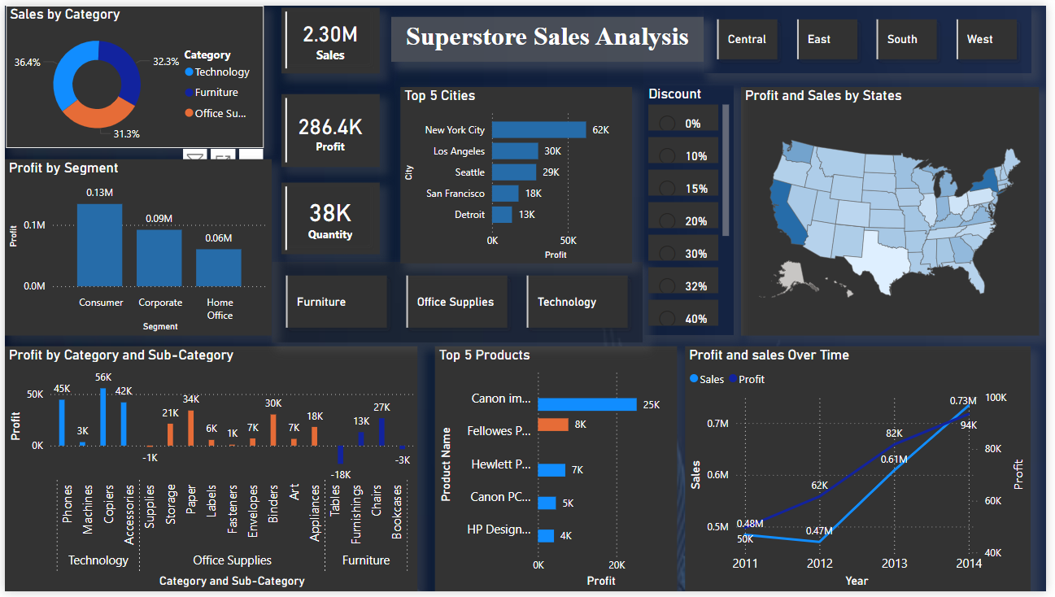

**Key Performance Indicators (KPIs)**

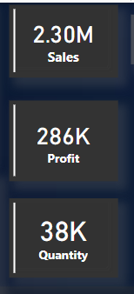

**Visualizations & Insights**

1. **Sales by Category:**
   * **Furniture (96.36%)** dominates sales, while **Technology (3.64%)** holds a minor share.
2. **Profit by Segment:**
   * Consumer segment reports **the highest losses (-6.3K)**, while corporate and home office segments have smaller losses.
3. **Top 5 Cities:**
   * **Saint Charles (137K profit)** is the most profitable city, followed by **Quincy (21K profit)**.
   * Some cities, such as **Lancaster (-1K profit)**, report negative performance.
4. **Profit by Category & Sub-Category:**
   * **Machines show a slight profit ($0.3K)**, while **Chairs (-6.7K) and Tables (-3.4K) contribute to major losses**.
5. **Profit & Sales by States:**
   * Certain states generate high revenue, while others show losses.
6. **Profit & Sales Over Time:**
   * Sales peaked at **$31.3K in 2014**, but profit was negative (-3.9K), indicating high operational costs or discounts.

**Interactivity Features**

* **Region-Based Filters:** Users can switch between Central and East regions.
* **Discount Analysis:** Analysing profitability at different discount levels (0% to 40%).
* **Category-Specific Insights:** Clicking on Furniture or Technology updates all relevant visualizations.

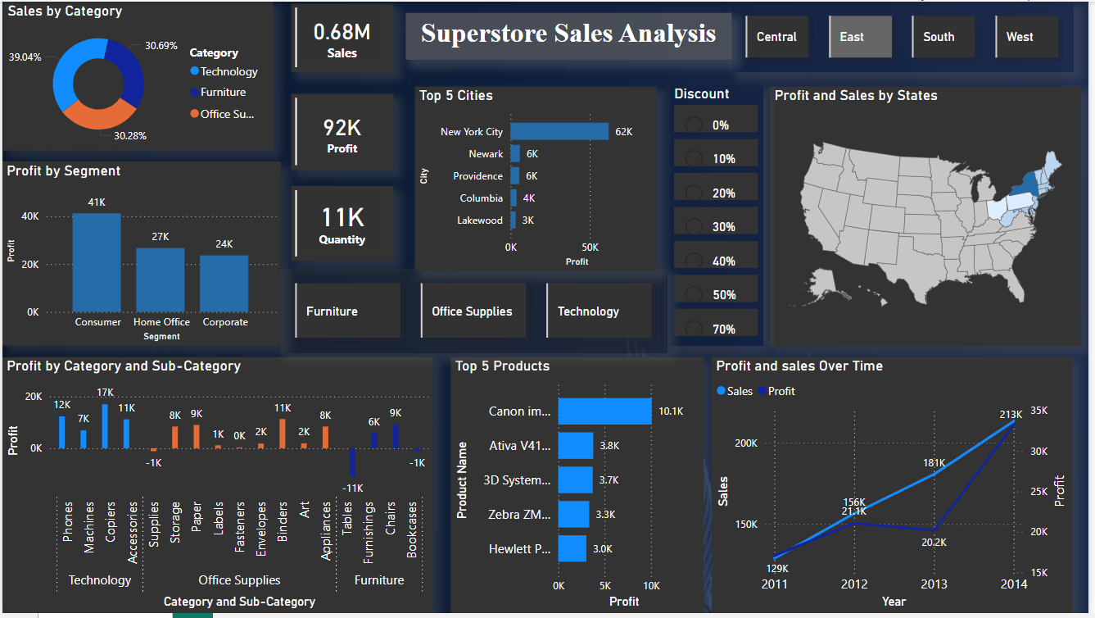

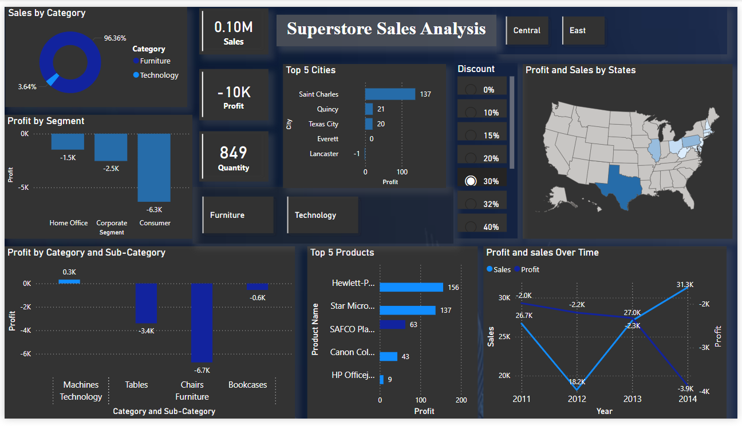

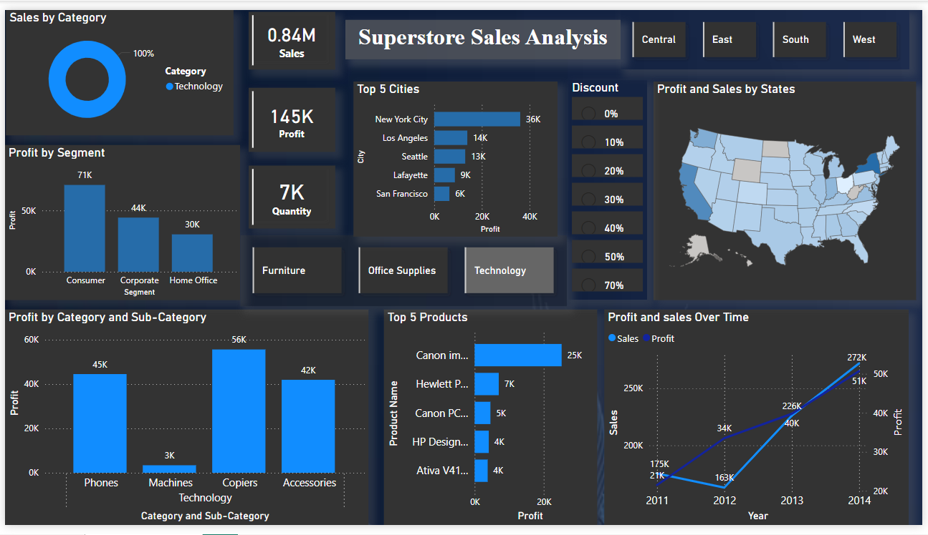

**Key Findings**

* **Profitability Issues:** Despite high sales, certain product categories contribute to significant losses.
* **Regional Performance:** High-performing states and cities should be the focus for expansion.
* **Product Performance:** Some furniture items (e.g., **Chairs and Tables**) cause major financial losses.
* **Sales Trends:** Sales are increasing over time, but profitability fluctuates due to **high discount rates**.

**Business Recommendations**

* **Reduce Discounts on Low-Margin Products** to improve profitability.
* **Target High-Performing Regions** for expansion opportunities.
* **Reassess Furniture Pricing Strategy** to reduce losses.
* **Optimize Cost Management** in loss-making segments.

**Challenges & Solutions**

* **Negative Profits:** Requires revisiting discount policies and pricing strategies.
* **Data Inconsistencies:** Addressed by standardizing product categories and ensuring accurate calculations.
* **High Discount Impact:** A structured discounting strategy can help retain customers while improving profit margins.

**Conclusion**

This analysis highlights key sales trends and profitability concerns, providing actionable insights for product pricing, regional expansion, and cost optimization. Future improvements in analytics, customer segmentation, and operational efficiency can drive sustainable growth.

**Future Improvements**

* **Customer Segmentation:** Implement targeted marketing and personalized discounts.
* **Product Optimization:** Phase out low-performing products and introduce high-margin alternatives.
* **Regional Strategy:** Focus expansion on high-profit regions with tailored pricing.
* **Operational Efficiency:** Optimize supply chain and automate inventory management.